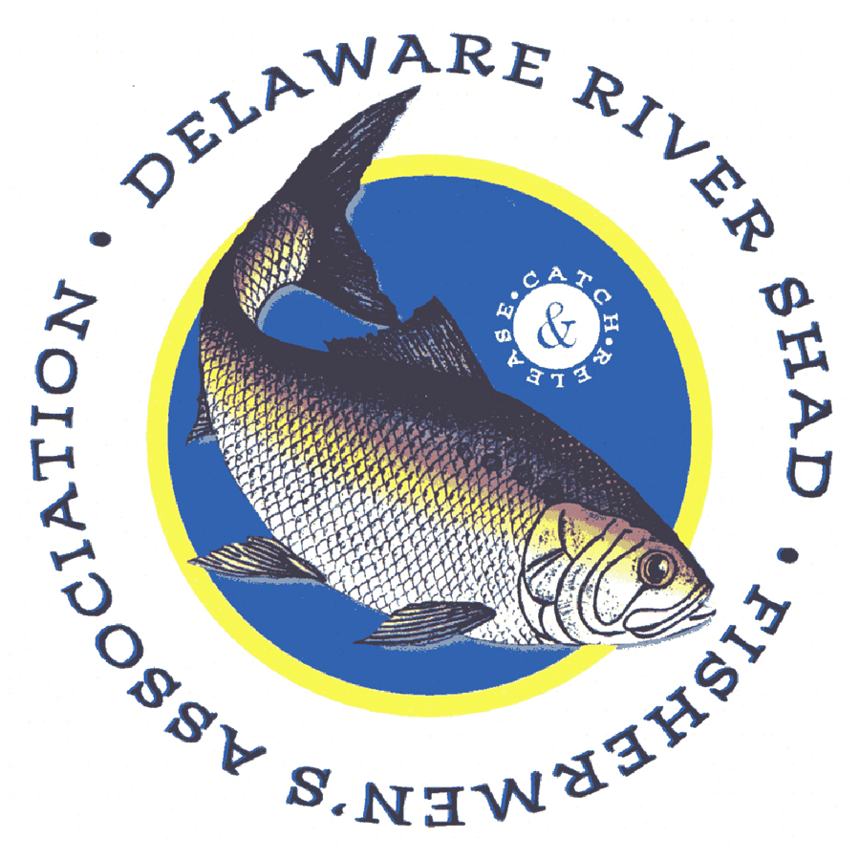

DRSFA MEMBERSHIP APPLICATION

Please fill out the below information and mail with your check or money order to:

DRSFA
2440 W. Columbia St.
Allentown, Pa 18104

NAME: ________________________________________________________________

STREET ADDRESS: _____________________________________________________

CITY: _____________________________________ STATE: ______ ZIP: __________

PHONE: ___________________________ EMAIL: _____________________________

LEVEL OF MEMBERSHIP:
____ BASIC $10

____ PATRON $25, includes free DRSFA patch.

____BENEFACTOR $45, includes free DRSFA hat.

____ LIFE $150, includes free DRSFA hat and DRSFA Patch.

Your membership helps to support:
- This web site. (DRSFA.org)
- Continued updates on shad, fishing, and Delaware River ecology.
- Shad restoration actions.
- Youth fishing education programs such as Youth Fishing Education Day and Shad in Schools.
- Youth scholarships.
- Meaningful programs at meetings.
- An informative newsletter.
- Actions which promote the welfare of the Delaware River and shad fishing.

