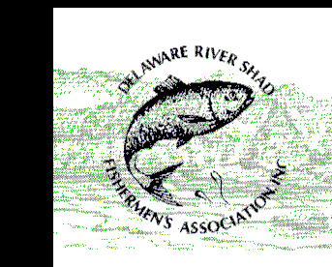
DELAWARE RIVER SHAD FISHERMEN’S ASSOCIATION
NAME: _______________________________________________ DATE:___________________________
TRIP # _______ BOAT WADING SHORELINE (CIRCLE ONE) START TIME: __________ END TIME: __________
LOCATION: ______________________________________ TOTAL CATCH: _________________
Species | Length – Inches | Weight – Pounds | Kept? (Y/N) | Gender (M/F/U) | Tag #
ANGLER SKILL LEVEL: NOVICE INTERMEDIATE EXPERIENCED (CIRCLE ONE) COMMENTS:_______________________________________________________________________________________________________________________________________________________________________
Mail to:
Cooper Barshinger
3155 Federal Road U.S. Route 209
Bushkill, PA 18324
cbarshinge@ pa.gov
DELAWARE RIVER SHAD FISHERMEN’S ASSOCIATION
NAME: _______________________________________________ DATE:___________________________
TRIP # _______ BOAT WADING SHORELINE (CIRCLE ONE) START TIME: __________ END TIME: __________
LOCATION: ______________________________________ TOTAL CATCH: _________________
Species | Length – Inches | Weight – Pounds | Kept? (Y/N) | Gender (M/F/U) | Tag #
ANGLER SKILL LEVEL: NOVICE INTERMEDIATE EXPERIENCED (CIRCLE ONE) COMMENTS:___________________________________________________________________________________________________________________________________________________________________________
Mail to:
Cooper Barshinger
3155 Federal Road U.S. Route 209
Bushkill, PA 18324
cbarshinge@ pa.gov

